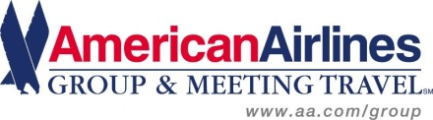

Creation Entertainment has partnered with American Airlines to provide our attendees a 5% discount for the Grand Slam Convention in Burbank, California. The valid travel dates for this discount are February 12 through February 20th 2013. You can easily access American’s fares and apply this discount by going to www.aa.com to book your flight. Place the below Promotion Code in the promotion code box and your discount will be calculated automatically. This special discount is valid off any applicable published fares listed for American Airlines, American Eagle, and American Connection. International originating guests will need to contact your local reservation number and refer to the Promotion Code.
You may also call 1-800-433-1790 to book your flights, please refer to the Authorization Number below when you call. Please note there is a reservation service charge for all tickets issued by phone. Please use our preferred partner, American Airlines when you can because of the benefits provided to you as a traveler and to our organization for extended partner value.

Promotion Code: 5823BW

Terms and Conditions: http://www.aa.com/i18n/businessPrograms/groupsMeetings/gmt_terms.jsp

Are you an AAdvantage member?



